How to fill up your JU-Print balance.
You need to be on either on a school computer or connected to Eduroam network.
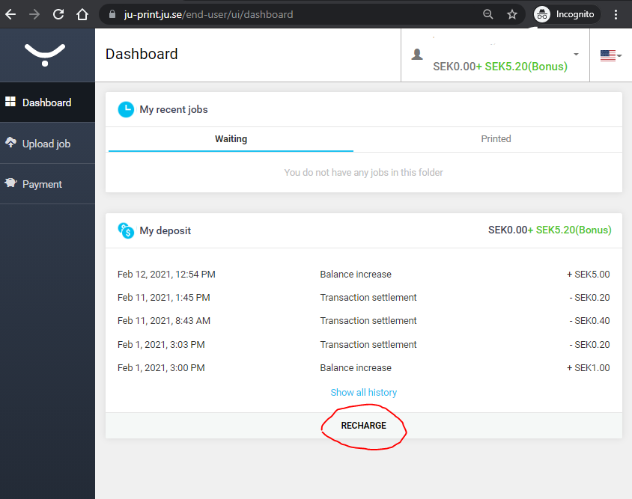
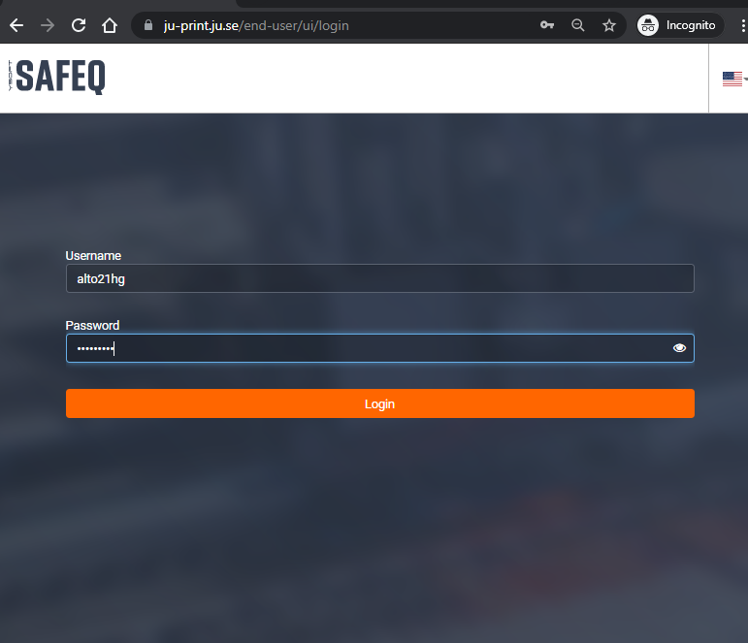
Go to https://ju-print.ju.se/
Once you logged in you can choose to Recharge Credit och type in the amount (minimum 50kr)
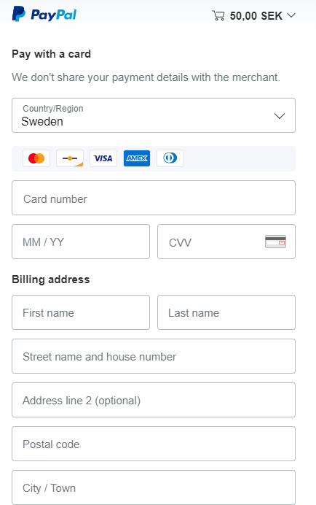
PS: Paypal is the Service but you don’t need to have a Paypal Account, as you can checkout as a guest just with a credit card.
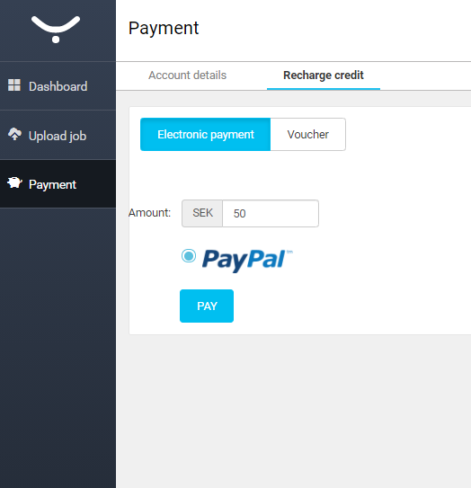
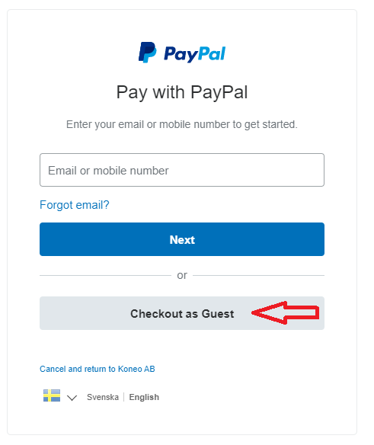

*Type in your email address on the next page and fill in you details to finish the payment.

